Weekly Research Report Studio 5

Student name :Zihan Liu

Report date : 21/3/2024

What did you do this week?

I implemented the complete static homepage using Vue this week

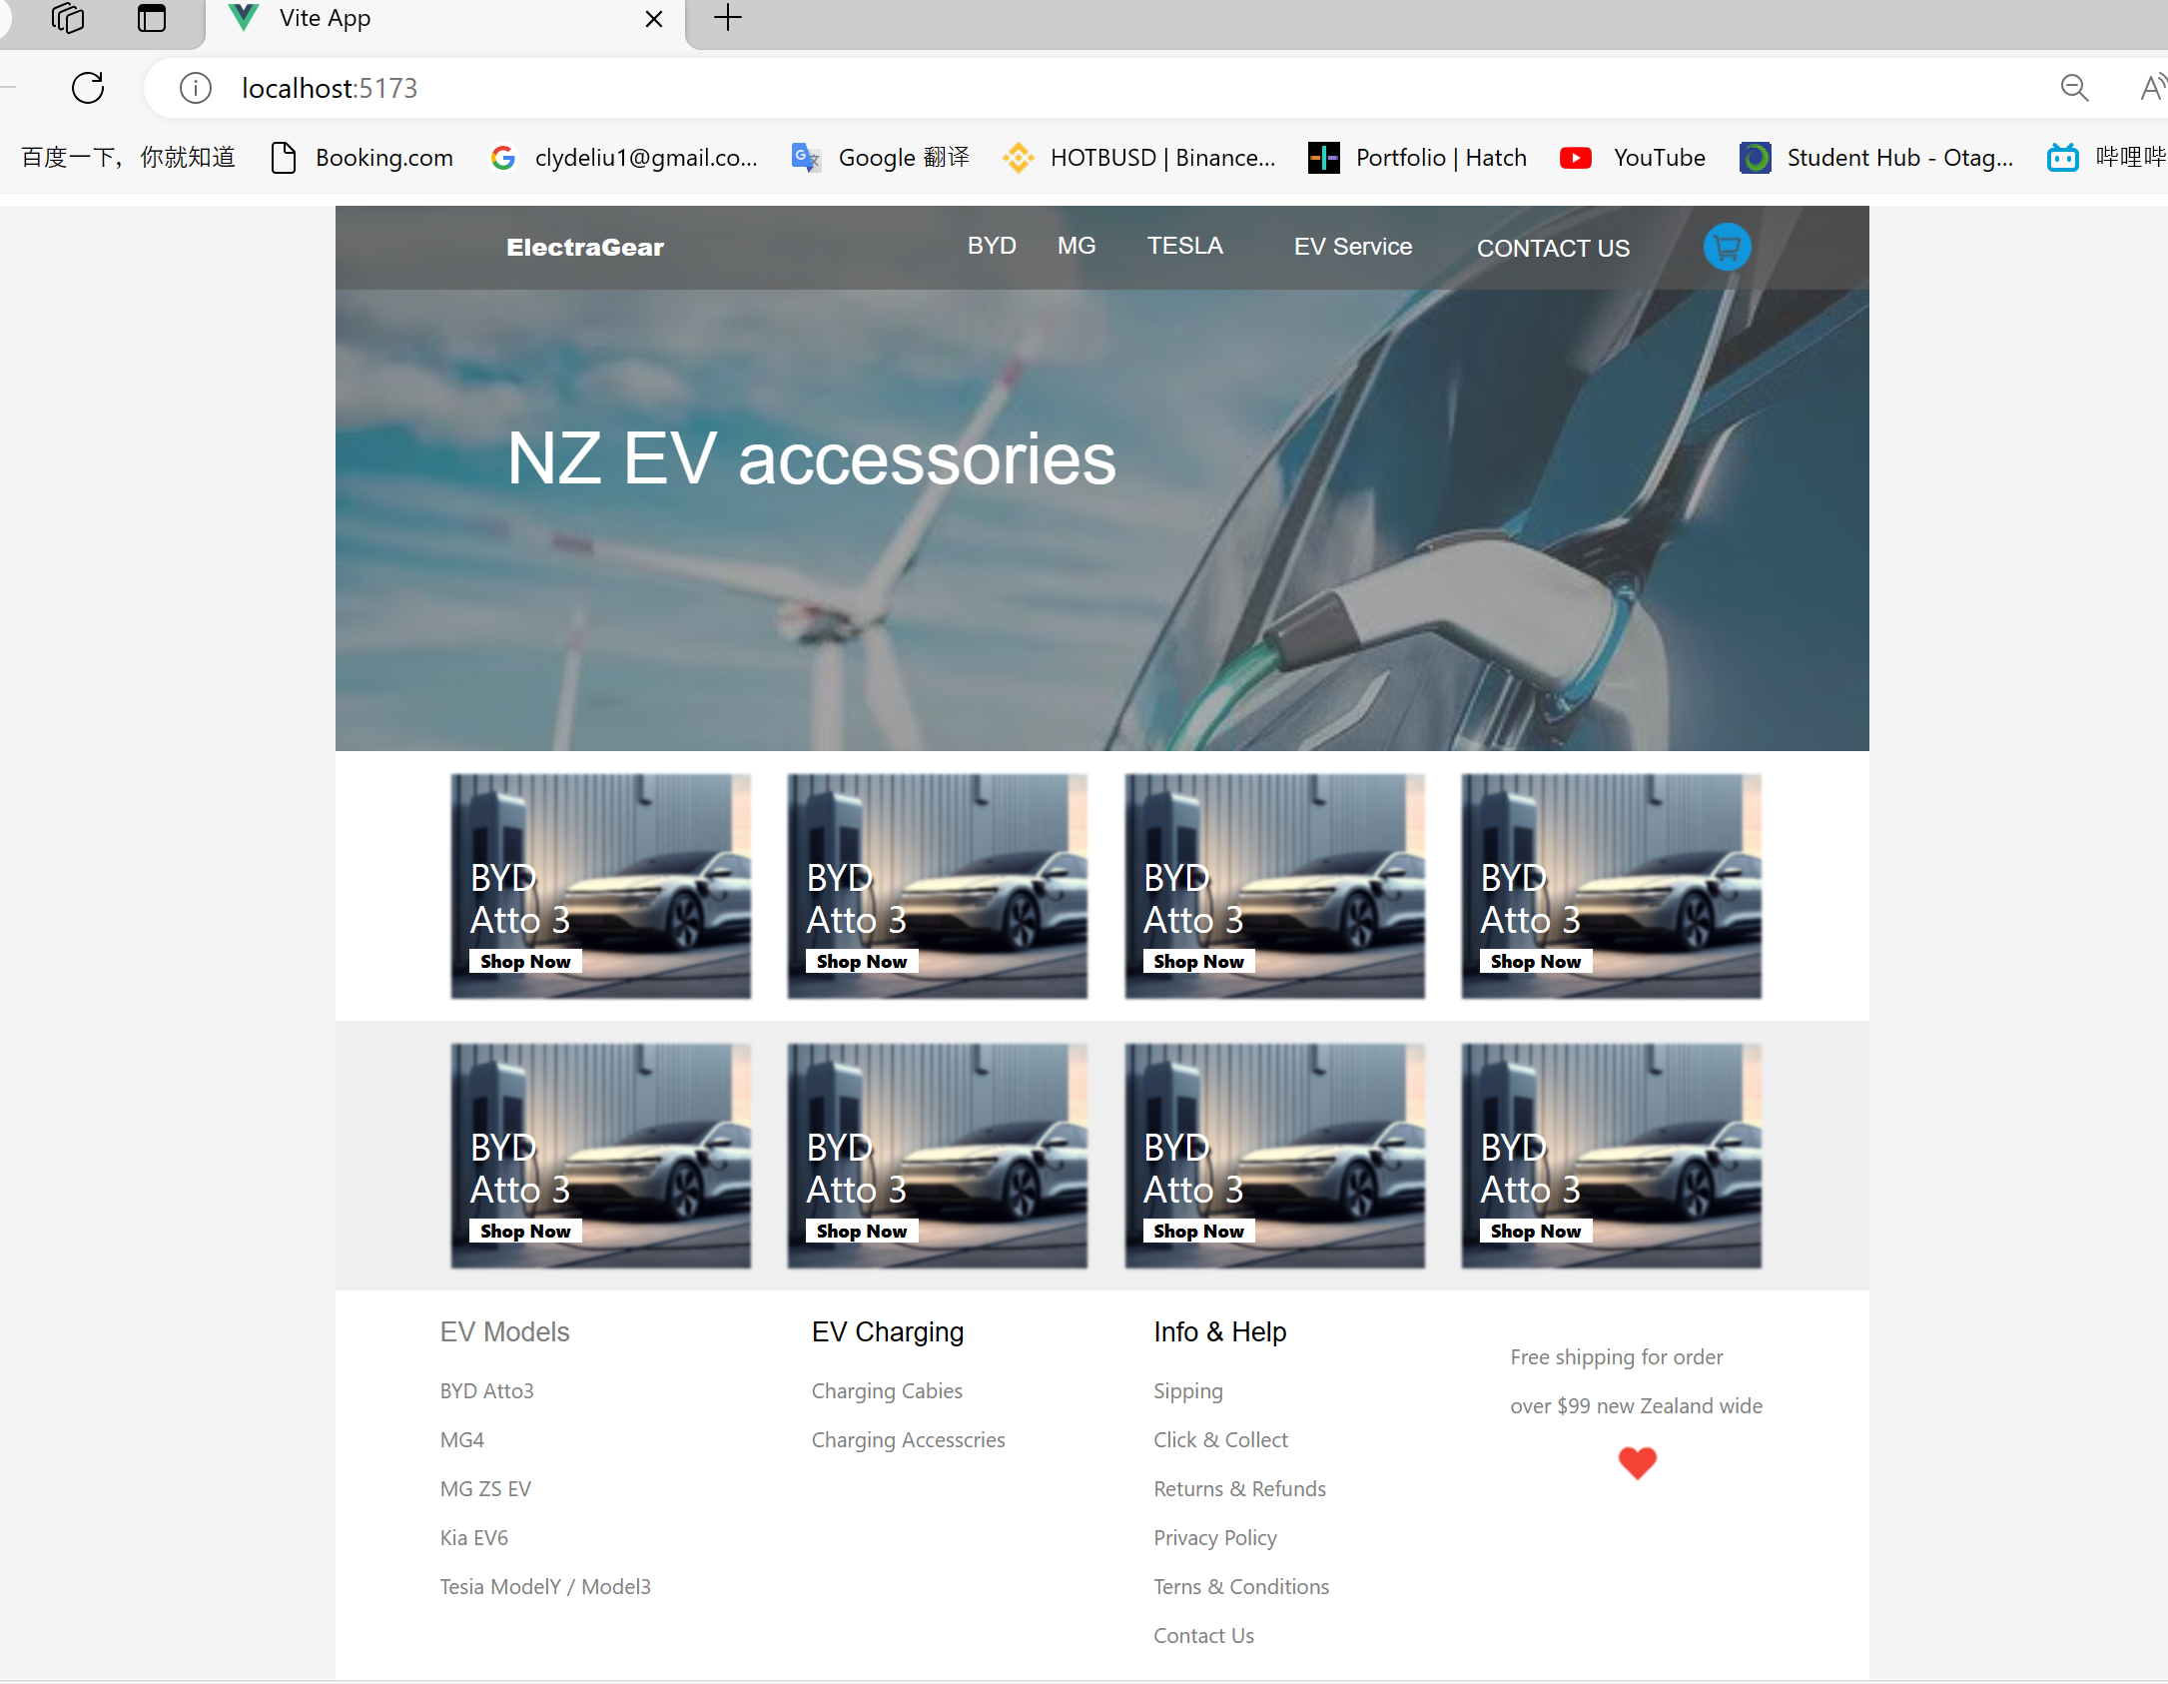

Designed the content for multiple product detail pages using Figma.

What are you planning to do next week?

*PERSENTATION   
FINAL DOCUMENTATION*

Do you need help with anything?